

**APP EXPLANATION**

Reference code: <https://snack.expo.io/@palak_bhatnagar/my-first-app>



In this line we are importing library react and also component which are Button, View and Text from react library.



In line 2 we are importing component from react-native library.



Leave 2-3 lines for spacing



In line 5 we are creating class WelcomeText like we do in JavaScript. Extends component is like we have done for the angry bird’s game for base class. Component is type of parent and which comes under component are type of child of component.



In line 6 we are commenting as we do in JavaScript.



Leave 1 line for spacing.



This **render** function is important to add without adding function render the class WelcomeText will not work.



This **return** function is also same as the function render.



We are setting the title as “Button”.





The round bracket of return function closing.



The curly bracket of reader function closing.



The curly bracket of class WelcomeText function closing.



Leave 1 line for spacing.



Export default is the syntax to write the code.

Then are calling the class App.js:



Extends Component you understand.

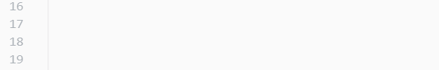

Leave 3-4 lines for spacing.



This **render** function is important to add without adding function render the class App will not work.



This **return** function is also same as the function render.



Calling one of the component like we called button in class WelcomeText.



This is type of CSS margin top means how much you will increase the number it will go more downer. Then “This is my first app” is just a text. We are writing this line in the third component text.



Calling class WelcomeText.



Closing view component.



The round bracket of return function closing.



The curly bracket of reader function closing.



The curly bracket of class App function closing.